

**Team ASSIGNMENT COVERSHEET**

**ITPM (COMP507) Assignment 1 Part 2**

|  |  |  |  |
| --- | --- | --- | --- |
| ***Team Number: STREAM58*** | ***Lab Time: TUES 10-12*** | | ***Lab TA: DANIEL/NIKITA*** |
| ***Student ID***  ***1. 14880978***  ***2. 20211429***  ***3. 23200829***  ***4. 19078256*** | ***First Name***  ***Edward***  ***Logan***  ***Flynn***  ***Celine*** | | ***Surname***  ***Keith***  ***Shugg***  ***Wilson***  ***Bilbao*** |
| ***Team Name:*** ***EFLC*** | | | |
| ***TA names:*** ***Daniel Vaipulu and Nikita Reghu Pillay*** | | | |
| ***Assignment due date:***  **Friday 6th Oct 2023 (extension granted by Ramesh Lal on 1st Oct)** | | ***Date & time submitted:***  **Wed 4th Oct 9:00am** | |

Please read the following and place an X next to each statement to indicate your understanding:

|  |  |
| --- | --- |
| It is my team’s responsibility to keep a copy of the assignment. | x |
| The team has signed and read the Student Statement below. | x |
| The team understands that a software program (Turnitin) that detects plagiarism and copying may be used on my assignment. | x |

***Plagiarism and Dishonesty are methods of cheating for the purposes of General Academic Regulations (GAR) http://www.aut.ac.nz/students/regulations.htm***

**Student’s Statement:** This assessment is entirely our team’s work and has not been submitted in any other course of study. The team will submit a copy of this assessment to Turnitin if required. In this assessment, the team has acknowledged that to the best of the team’s ability:

* The source of direct quotes from the work of others
* The ideas of others (includes work from private or professional services, past assessments, other students, books, journals, cut/paste from internet sites and/or other materials)
* The source of diagrams

Signature:

1. _______________________ Date: _____**01/10/23**_____________



1. _______________________ Date: _____**01/10/23**_____________

1. _______________________ Date: _____**01/10/23**_____________
2. __**Celine Bilbao**______ ___ Date: _____**01/10/23**_____________

*The information on this form is collected for the primary purpose of submitting your assignment for assessment. Other purposes of collection include receiving your acknowledgment of plagiarism policies and attending to administrative matters. If you choose not to complete all questions on this form, it may not be possible for the Faculty of Design and Creative Technologies to accept your assignment.*

# **Business Case**

## Date: 14/08/23

## Author: Edward Keith

### Project Name: EFLC

|  |
| --- |
| 1.0 Introduction/Background AUT's School of Engineering, Computer, and Mathematical Science (ECMS) offers the Bachelor of Computer and Information Sciences qualification. One of the core components of this degree is the R&D paper, a final year two-semester course. It enables students to undertake industry-based projects, gaining valuable experience for IT roles before they enter the workforce. This proposal outlines the plan to investigate two (2) cloud-based Project Management Software (PMS) alternatives to MS Project, aiming to save costs for the university, enhance students' learning experience, and increase the number of successful R&D projects. |
| 2.0 Business Objective ECMS aims to achieve a 3 to 5% growth in BCIS intake by providing industry-based teaching and offering choices for PMS. The transition from individual MS Project licenses to cloud-based alternatives is expected to reduce software costs by almost $1,200,000 per year for the next three years, aligning with the school's growth and savings objectives. |
| 3.0 Current Situation and Problem/Opportunity Statement ECMS's current reliance on MS Project (on-prem) leads to high costs for individual licenses. Based on the savings data provided, the university spends $1.2M per year on the licenses. An opportunity exists to identify 2 cost-effective cloud based project management software alternatives that align with the school's business objectives. |
| 4.0 Critical Assumptions and Constraints  * **Students**: 1000 students per year (considering two semesters). The number of students is a critical assumption as these will be fixed costs. 350 students enrolling in S1 and 150 students in S2 per academic year until 2026. The R&D project they are undertaking is a two-semester project, meaning you need to consider students from the previous year when working out costing. This equates to a total number of 1000 students per year (150 from the previous year combining with 350 in Semester 1, then 350 from Semester 1, coming with the 150 new students in Semester 2). Domain knowledge in this area provides the information for this assumption. * **Cost Impact**: $200,000 for the project, with potential future savings. * **Infrastructure**: Sufficient existing infrastructure has been identified. * **Internet Charges**: Fixed at $6 for 2024, increasing by 10% annually until 2026. * **Additional constraints**: There is a constraint in internet cost increasing per year beyond 2026 – cloud computing requires constant access, which cannot be predicted at this point. Additionally, cloud versions of the software are not always full-featured. If access is needed for the R&D project, having internet access is not guaranteed outside of the labs – this may be an accessibility issue when needing to use the PMS outside of the lab environment. |
| 5.0 Analysis of Options  * **Keep MS Project**: Continue as is with the current software. * **Use Cloud-Based Alternatives**: Transition to one of the cloud-based PMS. * **Customized Selection**: Allow students to pick a PMS based on what their R&D project employer uses. * **In-House Solution**: Develop a PMS solution for the university internally. |
| 6.0 Recommendation  * We recommend transitioning to a cloud-based Project Management Software (PMS). This would be an alternative to Microsoft Project and would reduce costs for the university. |
| 7.1 Functional Project Requirements  * **Review Cloud-Based PMS:** Identify and select two cloud-based Project Management Software (PMS) for review, excluding Microsoft Project. * **Evaluate the selected PMS**: based on specific criteria relevant to the R&D course, such as features, ease of use, cost, support, and integration capabilities. * **Investigate Microsoft Project 2019:** Analyse the features and functionalities of Microsoft Project 2019 (currently used by AUT) to establish a baseline for comparison. Identify specific elements that will be used to compare the two selected cloud-based PMS. * **Develop Wiki Content:** Create content for the Wiki that describes and compares the selected PMS across the process groups of Initiating, Planning, Executing, Monitoring/Controlling, and Closing. Ensure that the content adheres to the word limit of 4,500 words and includes supporting materials from trusted sources. * **Transition Resources:** Identify and outline the resources needed for the transition from MS Project to a cloud-based option, including technical infrastructure, human resources, development, and accounting costs. * **Develop a transition plan**: This outlines the steps, timeline, and responsibilities for implementing the selected PMS. * **Quality Assurance and Testing:** Define quality goals and standards for the Wiki project. Implement a quality assurance process that includes regular reviews, testing, and validation to ensure the Wiki meets the defined quality goals. * **User Training and Support:** Develop training materials and support resources to assist students and faculty in using the selected PMS. |
| 7.2 Non-functional Project RequirementsAccessibility: The PMS Wiki must be accessible to all students enrolled in the R&D course, both on and off-campus, and considering potential internet access limitations outside the labs.  * **Usability:** The Wiki interface should be user-friendly, with easy-to-understand navigation and clear, concise content to facilitate use for students with varying levels of technical ability. The R&D project covers all majors from the BCIS degree, so it should be usable for all students in this course. * **Reliability:** The selected cloud-based PMS must offer consistent performance and availability, minimising downtime and ensuring students can access the tools when needed. This is essential as Microsoft Project is locally hosted and has minimal downtime. * **Scalability:** The system must be able to handle the expected number of existing and incoming students and adapt to growth in enrolment in future years. * **Security:** The Wiki and selected PMS must comply with relevant AUT network and privacy security standards. * **Quality Assurance:** Implementation of quality control measures to ensure that the Wiki meets the high-quality goals stated in the scope, including regular reviews and user testing. * **Cost-Efficiency:** The project must meet the allocated budget of $200,000 and aim to achieve the anticipated savings of $1,200,000 per year for three years. |
| 8.0 Budget Estimate  * **Allocated Budget**: $200,000 for the Wiki project. |
| 9.0 Financial Analysis (see end of section for report)  |  | | --- | | * **Discount Rate:** 8% | | * **Savings:** $1,200,000 per year for three years | | * **Students:** 1000 students per year (350 Semester 1, 150 Semester 2) | | * **Initial Cost:** $200,000 for the project start | | * **Internet Charges:** Fixed at $6 for 2024, increasing by 10% annually until 2026 | | * **Usage Fee:** The usage fee for the PMS is expected to be $15.00 per user/year. It is estimated that up to 350 students will enrol in the R&D course in Semester 1 and 150 in Semester 2 in an academic year till 2026. | |
| 10.0 Schedule Estimate  * **Planning Start**: 1st August 2023. * **Planning Finish**: 30th October 2023. * **Product Launch**: 1st February 2024. * **Product Life**: Until 2026. |
| 11.0 Wiki Content and Comparison Framework  * **Comparison Framework**: Develop a structured framework for comparison. * **Supporting Materials**: The Wiki must be supported by related materials from trusted public domain resources and academic journals if users want to delve deeper into any areas of interest. * **Quality Goals**: Identify and clearly state the quality goals in the scope statement document, ensuring a high-quality Wiki. * **Word Limit**: The Wiki project is expected to be no more than 4,500 words. |
| 12.0 Potential Risks  * Team engagement * Client issues * Triple constraint * Fuzzy scope, time, and costs. |

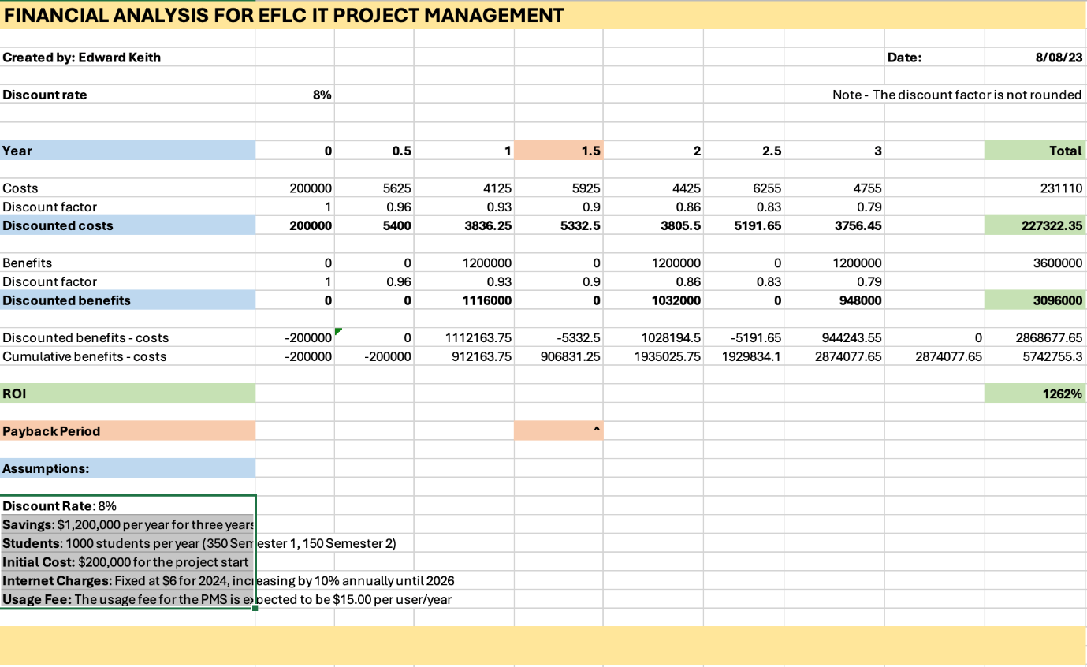

# **Stakeholder Register**

## Author: Flynn Wilson

## Date: 18/08/2023

|  |  |  |  |  |
| --- | --- | --- | --- | --- |
| **Name** | **Position** | **Internal/External** | **Project Role** | **Contact Information** |
| **Edward Keith** | Student | Internal | Project Leader | rkh0526@autuni.ac.nz |
| **Logan Shugg** | Student | Internal | Team member | bby9810@autuni.ac.nz |
| **Celine Bilbao** | Student | Internal | Team member | qck5607@autuni.ac.nz |
| **Flynn Wilson** | Student | Internal | Team member | zfp6323@autuni.ac.nz |
| **Daniel Vaipulu** | Teaching Assistant | Internal | Product Owner | [Daniel.vaipulu@aut.ac.nz](mailto:Daniel.vaipulu@aut.ac.nz) |
| **Nikita Reghu Pillay** | Teaching Assistant | Internal | Product Owner | jcp8893@autuni.ac.nz |
| **Dr Stephen Thorpe** | Senior Lecturer | Internal | Product Manager | [stephen.thorpe@aut.ac.nz](mailto:stephen.thorpe@aut.ac.nz) |
| **Dr Ramesh Lal** | Senior Lecturer | Internal | Product Manager | Ramesh.lal@aut.ac.nz |
| **BCIS Students** | Student | Internal | Testers | N/A |
| **Nurul** | BCIS Program Director | Internal | Project Sponsor | [nurul.sarkar@aut.ac.nz](mailto:nurul.sarkar@aut.ac.nz) |
| **Minh** | Head of Computer Sciences | Internal | Senior manager | mnguyen@aut.ac.nz |
| **ICT Director** | ICT Director | Internal | Consultant | N/A |
| **PMS Provider 1** | Software Vendors 1 | External | Suppliers | N/A |
| **PMS Provider 2** | Software Vendors 2 | External | Suppliers | N/A |
| **Terry** | AUT Accountant | Internal | Senior manager | Accounting Department |

**Stakeholder Management Strategy**

## Author: Celine Bilbao

## Date: 22/08/2023

|  |  |  |  |
| --- | --- | --- | --- |
| **Name** | **Level of Interest** | **Level of Influence** | **Potential Management Strategies** |
| **Nurul Sarkar** | Low | High | When experiencing financial constraints, Nurul, as the project sponsor is the go-to person as his role is pivotal in ensuring sufficient funds are there for the project’s progress. In order to keep him informed, team members regularly provide status updates and project progress reports, so he can make accurate decisions regarding financial support. |
| **Dr Stephen Thorpe** | High | High | As a product manager, Dr Stephen Thorpe significantly contributes to the success of the project. His knowledge is necessary to ensure that the objectives are completed accurately. By actively engaging in his lectures and participating in discussions, team members gain insights on clear tasks to achieving project goals. |
| **Dr Ramesh Lal** | High | High | Dr Ramesh Lal, another product manager takes responsibility for understanding customer needs, setting accurate objectives and making sure the project meets stakeholder expectations. He works closely with the team and it’s essential to attend his lectures as his knowledge allows the team to leverage the necessary tools and information needed to ensure correct execution of project. |
| **Daniel Vaipulu** | High | High | Daniel as a product owner contributes highly to the project as he acts as the bridge between the stakeholders, customers and team, so the project aligns with the needs of users. During lab sessions and client meetings, he actively engages and seeks updates on group’s progress, allowing him to stay informed and offer necessary assistance. |
| **Nikita Pillay** | High | High | Nikita is also a product owner, so team members are encouraged to actively communicate with her during weekly lab sessions and client meetings. Her role involves ensuring that the project delivers a valuable and and good quality product that meets business goals. |
| **Minh Nguyen** | Low | High | As a senior manager, Mihn brings valuable expertise to the project. Through providing regular project reports, team members keep Minh informed about the project’s progress. His role involves making strategic decisions and ensuring project aligns with overall goals. |
| **Gareth Terry** | Low | Medium | Terry, the accountant, contributes to the project by managing its financial aspect. By maintaining and tracking financial records, he enables the project to stay within the budget and optimise resource allocation. |
| **ICT Director** | Low | High | ICT Director is the project consultant, with their expertise, they provide valuable guidance and strategic insights to ensure the project aligns with industry practices. As the consultant, they support the team by helping to deliver efficient solution to problems that may arise. |
| **BCIS Students** | Low | Medium | BCIS students are testers, their involvement is necessary in identifying any areas of improvement within the project’s functionalities. Through testing, they provide any insights that could refine the project’s quality. |
| **PMS Provider 1** | Low | Low | PMS Provider 1, as a supplier, provides essential materials and resources needed for the project’s execution. They are responsible for making sure required resources are provided and are delivered within specified timelines. |
| **PMS Provider 2** | Low | Low | PMS Provider 2, another supplier is involved in effective supplier management, which includes negotiating favourable terms and monitoring delivering schedules. |
| **Edward Keith** | High | High | As a team leader, Edward possesses a clear understanding of project’s objectives and communicates efficiently, delegating tasks to ensure productivity. Moreover, he provides assistance to each team member by actively seeking updates and maintaining a comprehensive overview of the team's progress. |
| **Logan Shugg** | High | High | Logan, a team member, takes the initiative during team meetings by actively engaging with everyone, valuing their opinions, fostering a collaborative environment. He provides assistance when necessary and offers examples to help with the project. |
| **Flynn Wilson** | High | High | Flynn, another team member, contributes by completing assigned tasks to him, helping with the team's overall progress. |
| **Celine Bilbao** | High | High | Celine, a team member, seeks tasks during team meetings to ensure she’s contributing with the team’s objectives, and she frequently asks the leader questions to ensure she’s completing the tasks correctly. |

# **Project Charter**

## Author: Logan Shugg

## Date: 22/08/2023

|  |  |  |  |
| --- | --- | --- | --- |
| Project Title: EFLC IT Project Management | | | |
| Project Start Date: 1st Aug 2023 Projected Finish Date: 30th Oct 2023 | | | |
| Budget Information: $200,000 | | | |
| Project Managers: Ramesh Lal and Stephen Thorpe | | | |
| Project Objectives: The School of Engineering, Computer and Mathematical Sciences (ECMS) at Auckland University of Technology aims to increase intake into the Bachelor of Computer and Information Sciences intake by 3-5%. This will be achieved through providing industry-based teaching and offering choices for cloud-based Project Management Software (PMS). The transition from individual MS Project licenses to cloud-based alternatives is expected to reduce software costs by almost $1,200,000 per year for the next three years, aligning with the school's objectives. | | | |
| Success Criteria:Project is delivered for launch on the 1st of February 2024.  * Project stays within the $200,000 budget. * Project meets the functional and non-functional requirements outlined in the Business Case document. | | | |
| Approach:Make sure the scope is understood before the project is started.  * Identify what Project management document templates need to be used for the implementation and planning phase. * The Agile approach will be used as the proposed project is a software development project. * Make sure tasks are delegated according to team member's skillsets and completed according to the timeline. * Team members need to attend lectures and labs to keep UpToDate about what needs to be done. * Establish clear communication channels and regular updates with all stakeholders, including team members, product owners, product managers, IT staff, and vendors, through progress reports. * Stakeholders need to be collaborated with to get feedback and ensure alignment with the project's goals and expectations. * Identify potential risks at the start of the project and address issues as they arise as they could impact the triple constraint. * Use appropriate templates to address risks and ensure that potential issues are proactively managed. | | | |
| Roles and Responsibilities: | | | |
| **Name** | **Role** | **Position** | **Contact Information (Email & Phone)** |
| Edward Keith | High-level Project Analysis | Project Lead | 02102571783  rkh0526@autuni.ac.nz |
| Flynn Wilson | Stakeholder Management | Team Member | 0225991589  zfp6323@autuni.ac.nz |
| Logan Shugg | Timeline and File Management | Team Member | 0278143831  bby9810@autuni.ac.nz |
| Celine Bilbao | Stakeholder Strategy | Team Member | 0273656015  qck5607@autuni.ac.nz |
| Daniel | Product Owner | Teaching Assistant | N/A |
| **Signatures:**  **Celine: Celine Bilbao** **| | | |

# **Team Contract**

## Author: Logan Shugg and Edward Keith

## Date: 15/08/2023

## Version: 1

|  |  |  |
| --- | --- | --- |
| **Name** | **Date** | **Signature** |
| **Edward Keith** | **15/08/2023** |  |
| **Flynn Wilson** | **18/08/2023** |  |
| **Logan Shugg** | **15/08/2023** |  |
| **Celine Bilbao** | **18/08/2023** | **Celine Bilbao** |

**Code of Conduct:** As a project team, we will:

* Maintain good and open communication between team members. We will keep each other informed of progress and challenges. We will use agreed-upon methods of communication and actively listen and provide constructive feedback.
* Be respectful of each other and their opinions/ideas. We will try to foster inclusivity and promote a supportive working environment.
* Be responsible, i.e., completing tasks in a timely fashion. We will demonstrate accountability for ourselves and our work. We will commit to completing tasks in a timely and quality manner.
* Build and maintain trust. We will be honest, transparent, and consistent. We will respect each other’s decisions and collaborate to achieve our goals.

**Participation:** We will:

* Do equal amounts of work (regularly check in about workload).
* Attend all possible lectures and labs to gain clarity and understanding of the assignment.
* Keep up to date with assignment timelines and lab work.

**Communication:** We will:

* Read communications and acknowledge with a thumbs up.
* Respond to messages in a timely manner (i.e., within 24 hours)
* Discuss issues or problems when they arise.

**Problem-Solving:** We will:

* Seek help from external sources if struggling i.e., TA or lecturer.
* Discuss with other team members if struggling with practical aspects of the assignment.
* A weekly performance review will be conducted in the lab to assess participation and team contributions.

**Meeting Guidelines:** We will:

* Have a meeting at least once a week, and Edward will take minutes.
* Be on time and inform team members if you are running late/can’t attend.
* Come prepared to meetings.

**Consequences for behavior impacting team performance:**

If performance is found to be not in line with the team contract the following steps will be implemented:

* Team leader (Edward) to have a 1 on 1 meeting to discuss how team member can improve their contributions to the team.
* Project manager will be contacted in regard to non-compliance of the contract.
* Project manager to determine next steps.

# **Risk Register**

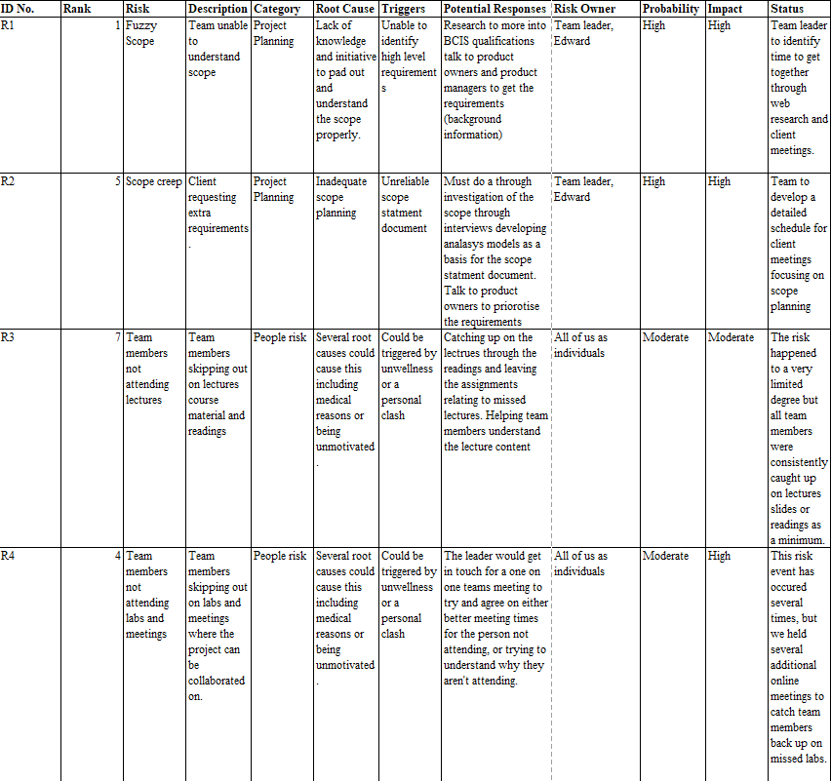

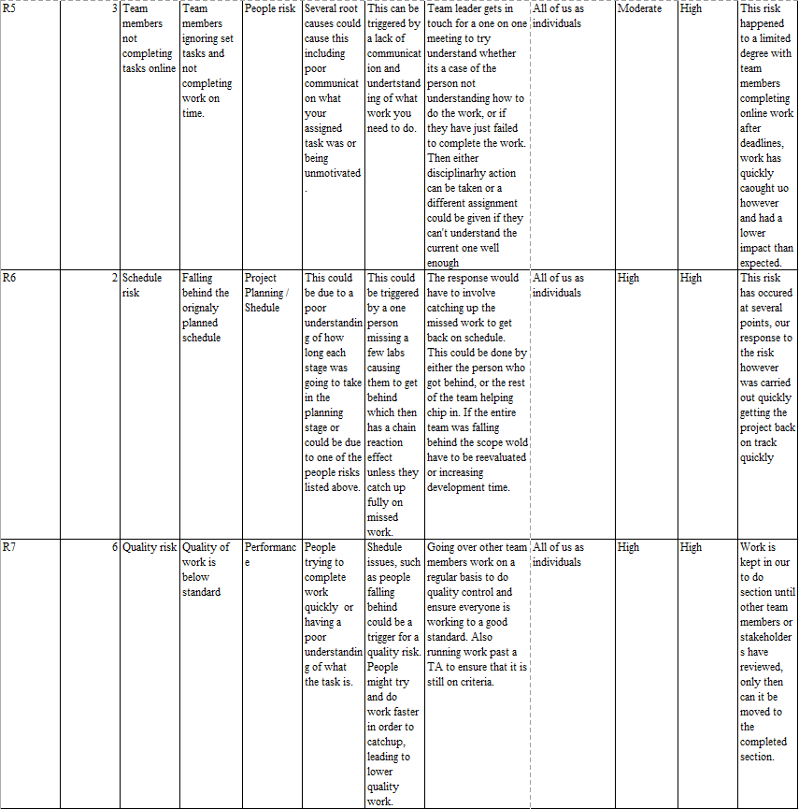

# **Issue Log**

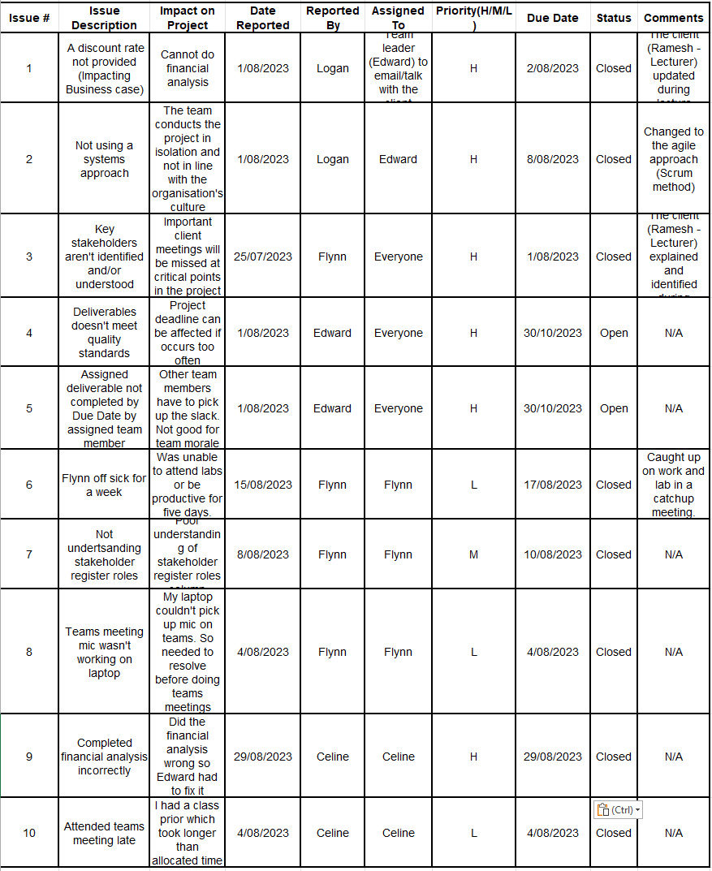

# **Project Milestone Report**

## Author: Edward Keith and Logan Shugg

## Date: 01/09/23 (updated)

|  |  |  |  |  |
| --- | --- | --- | --- | --- |
| Milestone | Date | Status | Responsible | Issues/Comments |
| Business Case Completed | 14/08 | Completed | Edward | Reviewed and small amendments done with Product Owner. Financial Analysis assigned to Celine (Not Completed) |
| Stakeholder Register | 18/08 | Completed | Flynn | Minor changes were made |
| Stakeholder Management Strategy | 29/08 | Completed | Celine | Needed extra Assistance from Edward |
| Team Contract | 15/08 | Completed | Logan and Edward | Needed prompting for signatures |
| Project Charter | 29/08 | Completed | Logan | Approaches needed editing |
| Risk Register | 23/08 | Completed | Flynn | Small changes |
| Issue Log | 23/08 | Completed | Logan | Miss-understanding of what it was initially. Small changes added |
| Financial Analysis | 14/08 | Completed | Edward | Assigned to Celine and not finished. Edward completed. |
| Peer Rating and Group Rating Form | 01/09 | Completed | Edward | None |
| Packaging with Cover Sheet | 01/09 | Completed | Edward and Logan | None |
| Part 1 Submission | 01/09 | Completed | Edward | None |

# **Kick-Off Meeting Minutes**

## Author: Edward Keith

## Date: 01/08/23

### Project Name: ELFC

### Meeting Objective:

Get the project off to an effective start by introducing key stakeholders, reviewing project goals, and discussing plans.

### Agenda:

* Introductions of attendees
* Review of Assignment 1 parts and sub-tasks
* Review of project-related documents and priority
* Discussion of how to structure the group working space on Teams
* Discuss and determine stakeholders in the project
* Availability of team members
* List of action items from meeting

**Attendees:**

Edward Keith, Logan Shugg, Flynn Wilson

Absent: Celine Bilbao

**Minutes:**

Discussion of how each part of the assignment is structured, when the due dates are, and which elements are required for Part 1 and Part 2. Compared task details to what has been covered in the lecture.

Downloaded document package for the assignment, unzipped, and went through it determining which templates were needed for each section of the assignment. These were then roughly organised into a hierarchy and given priority.

Discussed how the structure of the Teams workspace should be set up. How document sharing would be handled. Planned to create Teams partitions and have all the files hosted there, and work on them collaboratively.

|  |  |  |
| --- | --- | --- |
| **Action Item** | **Assigned To** | **Due Date** |
| Create partitions in Teams | Flynn | 01/08/23 |
| Upload relevant files to partitions | Logan | 01/08/23 |
| Create minutes for meeting and upload | Edward | 01/08/23 |

# **Prelim Team Meeting Minutes**

## Author: Edward Keith

## Date: 04/08/23

### Meeting Objective:

Recap on the kick-off meeting from the lab, catch Celine up on what we covered, and prepare for the week coming.

### Agenda:

* Team contract
* Team information and team roles determined and recorded
* Development of Teams environment
* Clarifying how to best use MS Project

**Attendees:**

Edward Keith, Logan Shugg, Flynn Wilson, Celine Bilbao

**Minutes:**

Started meeting with discussion of team roles, and covered agenda.

Team roles discussed (at least preliminary ones) and team information recorded. First deliverable of team information sheet was given to TA in lab – need to check if this also needs to be emailed.

Discussed how Logan will manage the MS Project timeline file and ensure that all deliverables are clear and have timestamps. We also discussed loading in all group members as assets so that we can incorporate costing and workload.

Discussed goals for next week and trying to find clarification on the exact deliverables of Assessment.

|  |  |  |
| --- | --- | --- |
| **Action Item** | **Assigned To** | **Due Date** |
| Investigate MS Project timeline | Logan | 01/08/23 |
| Read and digest Assessment Draft | Everyone | 06/08/23 |
| Create minutes for meeting and upload | Edward | 06/08/23 |

**Date and time of next meeting:** 08/08/23

# **Week 2 Team Meeting Minutes**

## Author: Edward Keith

## Date: 08/08/23

### Meeting Objective:

Continue from our previous meeting and establish procedures to ensure we stay on track.

**Attendees:**

Edward Keith, Logan Shugg, Flynn Wilson

Absent: Celine Bilbao

### Agenda:

* Make plans for agile development (scrum method etc)
* Stakeholder register completion
* Review assignment overview document
* Begin work on business plan

Discussed the scrum method and went over examples. We have decided to implement it into our project workflow and ensure that we are establishing contact with team members on a daily basis as opposed to one long weekly meeting.

Completed stakeholder details and began work on the stakeholder management techniques. Established a draft of the Power-Interest Grid for implementation into the stakeholder documents. Tried to determine which of the stakeholders would fit into which category – are they passive, active, involved or not?

Began work on business plan document.

Client reviewed the business case and gave feedback.

**Date and time of next meeting: Unknown**

# **Week 3 Client Meeting Minutes**

## Author: Edward Keith

## Date: 15/08/23

### Meeting Objective:

Plan for the coming week

**Attendees:**

Edward Keith, Logan Shugg

Absent: Flynn Wilson, Celine Bilbao

### Agenda:

* Clean up document filesystem
* Review business case with stakeholders and get feedback
* Check financial analysis for accuracy
* Project Charter
* Merge team contract, code of conduct and team information document (team docs)

Apologies from Flynn - notification of illness. Celine did not attend the lab – no notice.

We created a master team document, with all of the information from the assorted templates. This provides a clear and informative single location for all of the team data. Additionally, we updated the team contract to reflect updated team values, and take into account new lessons learned in the weekly lecture.

Team document was posted in Microsoft Teams, with an announcement to notify absent team members and request signature and confirmation. Due date is 18/08/23.

Reviewed business case with Daniel (Project Owner) who provided feedback and guidance on this document. Stakeholder engagement was achieved. Some updates need to be made to the business case before submission.

Reviewed updated financial analysis with Daniel. Confirmed figures were correct, made ready for input into updated business case.

Logan and Edward worked on the Project Charter, which incorporated a lot of information from other documents. Brought it in line with the completed documents so that it can be reviewed next week in the lab. Daniel said it seems complete.

**Date and time of next meeting:** Thursday this week – time TBC

# **Week 3** **Team Catch-up Meeting**

## Author: Logan Shugg and Edward Keith

## Date: 17/08/23 Start: 1:08pm End: 1:56pm

### Meeting Objective:

Touch base with members and ensure that the project is on track. Provide clarity regarding milestones and expectations.

**Attendees:**

Logan Shugg, Flynn Wilson

Celine Bilbao absent until 1.43pm

Absent: Edward Keith (apologies)

### Agenda:

* Review of work completed by Edward and Logan in Lab 4
* Assessment of team contract
* Discussion of team contract and signing if all parties agree
* Check that all team members have the correct Microsoft Teams settings for updates and notifications
* Check stakeholder documents and make sure they are complete (or make action items for completion by end of the week)
* Discussion of risk register and work start on this document
* Check the remaining to-do documents and see if any can be allocated
* Explain that Daniel will be checking our documents in the lab next week and how we need to have them ready for that
* List of action items from the meeting

**Minutes:**

* Notifications were checked on teams and changed so everyone receives them
* Contract needs to be signed by all parties by end of day Friday (18/08/2023)
* Flynn to finish Risk register before the lab on Tuesday
* Logan to finish Issue register before the lab on Tuesday
* Celine to finish Stake Holder Management Strategy before the lab on Tuesday
* Milestone report to be completed in the lab
* Edward to clean up the minutes document
* Stakeholder register completed and to be checked by Daniel in the Lab on Tuesday regarding empty columns

|  |  |  |
| --- | --- | --- |
| **Action Item** | **Assigned To** | **Due Date** |
| Issue Register | Logan Shugg | 22/08 |
| Risk Register | Flynn Wilson | 22/08 |
| Stakeholder Management Strategy | Celine Bilbao | 22/08 |

# **Week 4 Client Meeting Minutes**

## Author: Edward Keith

## Date: 22/08/23

### Meeting Objective:

Take stock of where we are on the project, work through the missing deliverables and get items checked off by stakeholders (with feedback) in preparation for submission.

### Agenda:

* Double check the financial analysis
* Sign the team contract
* Add more approaches and all of us sign the project charter
* TA to check Stakeholder Register
* finish/double check the issue register and risk register
* Check in with clients and get feedback

**Attendees:**

Edward Keith, Logan Shugg, Flynn Wilson, Celine Bilbao

**Minutes:**

Financial Analysis checked with Edward and Logan, with some clarification of the negative values. Work continued on the issue register. We went through the individual issues and confirmed dates and attribution. This will need to be expanded upon over the next week.

Ramesh attended the session and went through the stakeholder information with the lab. Provided feedback and guidance for Celine to complete the stakeholder management strategy. This lead to the entire group working on the stakeholder documents.

Based upon feedback from Ramesh, Edward updated the Business Case document to further expand upon the Problem/Opportunity Statement. This now sits at 1150 words. The Financial Analysis was also checked and approved. Flynn worked on the Risk register. This was then checked and approved by Ramesh. Work continued the Team Contract based upon stakeholder feedback.

|  |  |  |
| --- | --- | --- |
| **Action Item** | **Assigned To** | **Due Date** |
| Issue Register needs more items input | All | 29/08/23 |
| Stakeholder Management document needs to be finished | Celine | 27/08/23 |

**Date and time of next meeting:** 29/08/23